**ASSIGNMENT - 20.2**

**Problem Statement:**

Task 10: Enhance the task 8 (refer session 19, assignment 1) to calculate the top 3 state-wise sales for each company. You may use multiple reducers for this activity.

**Input:**

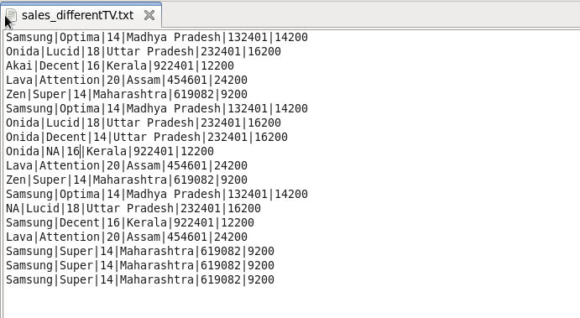

**Program:**

**Driver Class:**

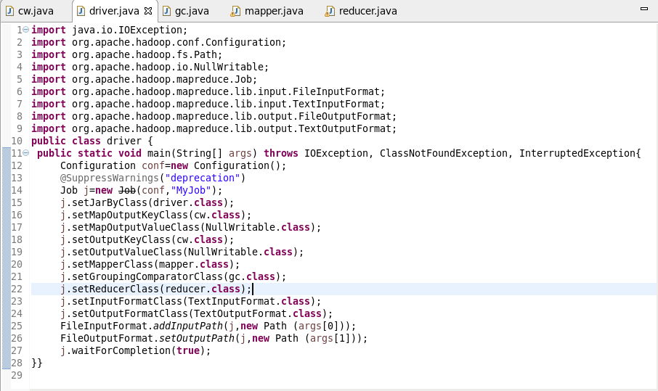

**CustomWritable Class:**

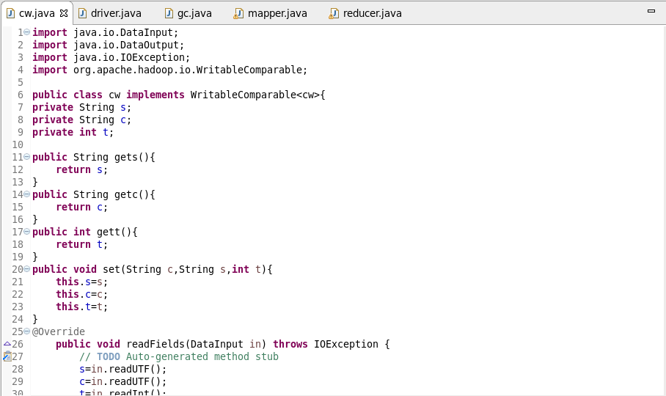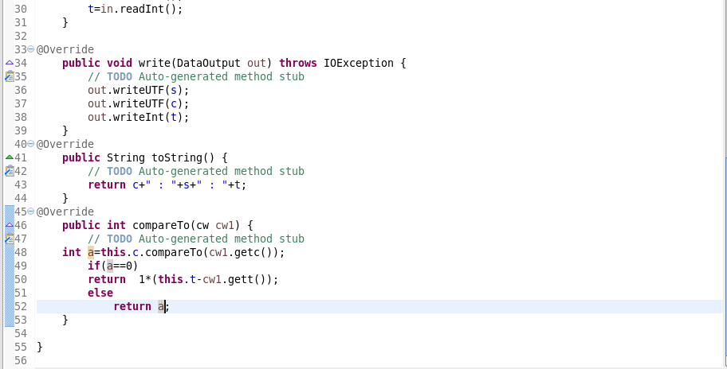

**GC Class:**

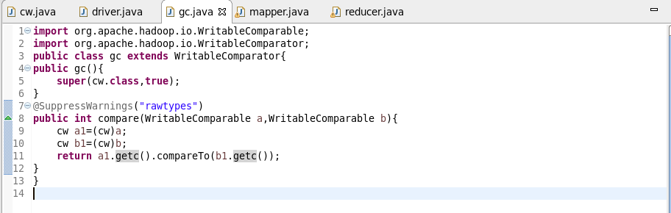

**Mapper Class:**

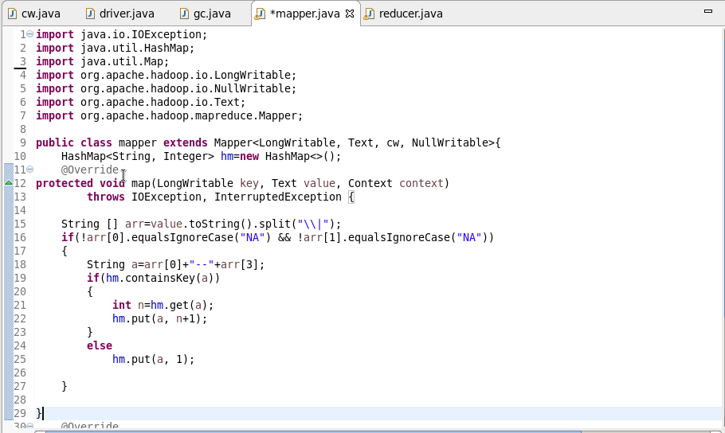

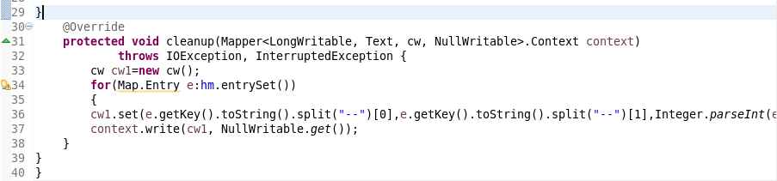

**Reducer Class:**

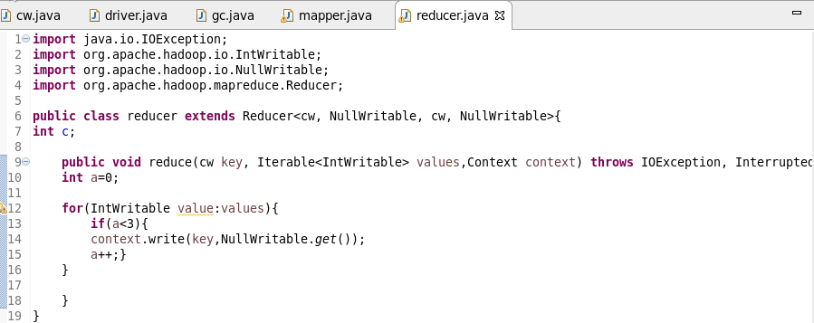

**Output:**

